**How to Submit a Zero Timecard**

1. Select Create
2. Select Create Timecard

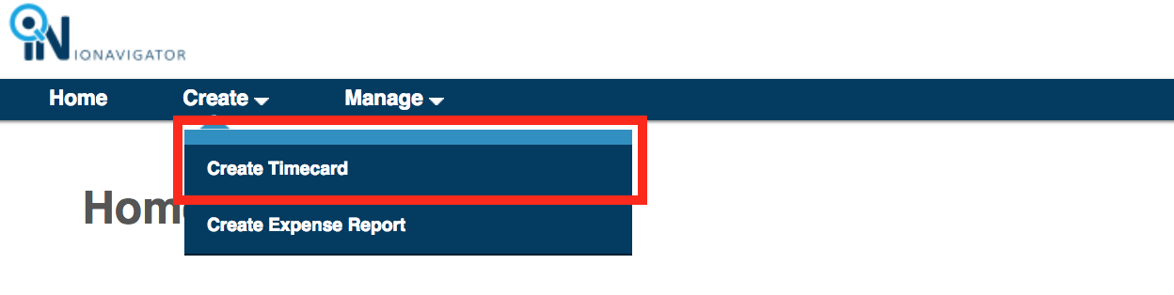

1. Delete the first timecard line

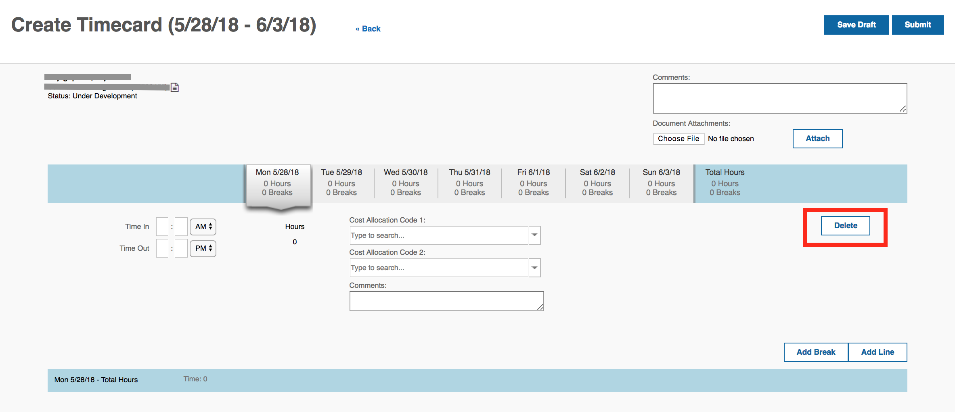

1. Click “Add Break”

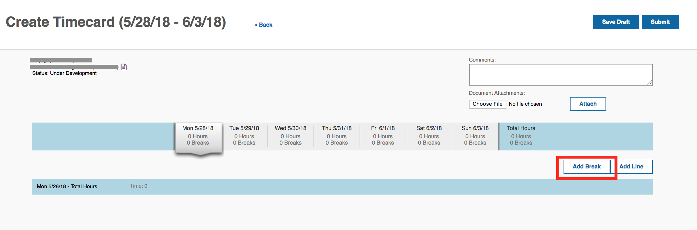

1. Select Break Type (DO NOT Select Rest Break)

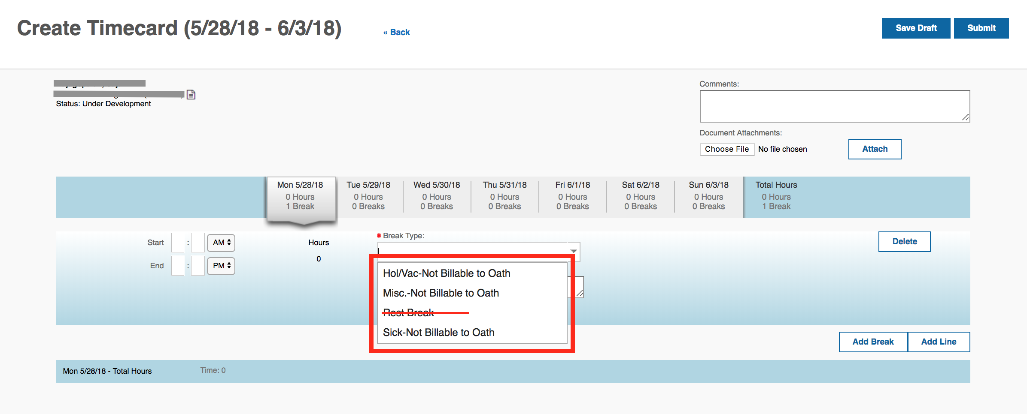

1. Add hours and Break Types to each day by repeating the above process.
2. Click Submit

